# Instructions

The Web development team has completed the initial development of their new web application and would like to get it up and running on their server. They have requested to be able to access the /development/website directory through their Windows desktops via a shared drive.

The would also like the Apache Web service to look for files within this directory, starting with the “Under Construction” page created previously.

They will also need to be able to access the system via SSH in order to manage services. Be sure to only allow necessary services through the firewall and configure network settings.

Once complete, please test the file share and Web site connections.

*HINT: You can reuse the network settings set by DHCP. You may need to install the Network Manager Tool. Disable SELinux security for the services to work properly.*

# Screenshots

Paste the required screen shots under each description.

1. Paste a screen shot showing the manually set network settings in the Network Manager TUI (**nmtui**) A screenshot of a computer

   Description automatically generated
2. Paste a screen shot showing the allowed services through the Firewall

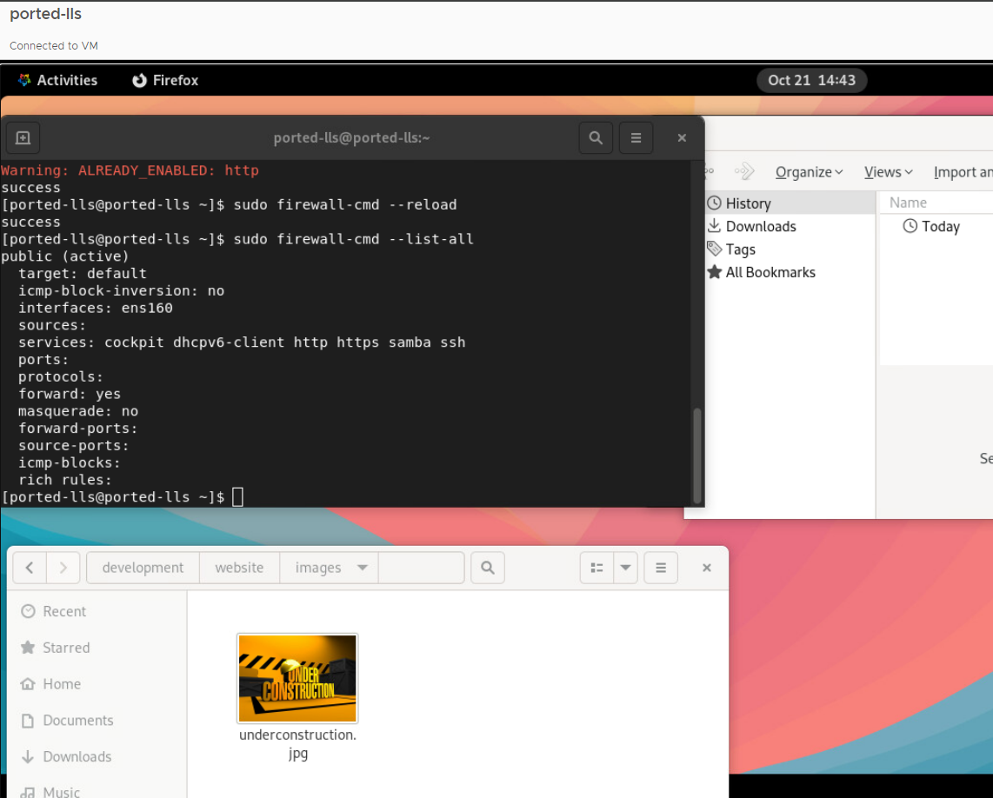

1. Paste a screen shot showing the Samba configuration settings

1. Paste a screen shot showing a Web dev user accessing the shared folder through File Explorer

1. Paste a screen shot showing the “Under Construction” Web page in a web browser. (Must use **http://**) A computer screen shot of a yellow and black construction site

   Description automatically generated

# Documentation

Record and explain all the steps you took to complete the task. Include any commands used, screen shots showing GUI interfaces, or any other information that would help you recreate the task.

**Note: You will be allowed to use this documentation to help you complete future assignments.**

**Documentation for Lab 7 - Linux Network Services**

**Step 1: Set Network Configuration Using nmtui**

* I manually set the network configuration using the **Network Manager TUI (nmtui)** tool. This allowed me to configure the IP address, gateway, and DNS settings for the server to ensure it was properly connected to the network.
* To access nmtui, I ran the following command:

sudo nmtui

* After configuring the settings, I saved the changes and verified that the server was properly connected to the network.

**Step 2: Configure the Firewall**

* I configured the firewall to allow necessary services through, including http, https, samba, and ssh, using the firewall-cmd command.
* The following commands were used to allow these services:

sudo firewall-cmd --permanent --add-service=http

sudo firewall-cmd --permanent --add-service=https

sudo firewall-cmd --permanent --add-service=samba

sudo firewall-cmd --permanent --add-service=ssh

sudo firewall-cmd –reload

* After adding these services, I verified the active firewall settings with:

sudo firewall-cmd --list-all

**Step 3: Disable SELinux**

To permanently disable SELinux, I edited the configuration file:

sudo vi /etc/selinux/config

SELINUX=disabled

After saving the file, I rebooted the system to apply the changes:

sudo reboot

**Step 4: Configure Samba for File Sharing**

* I configured **Samba** to enable the web development team to access the /development/website directory from their Windows desktops via a shared drive.
* I added the following configuration to the /etc/samba/smb.conf file to define the shared folder:

[WebsiteShare]

path = /development/website

valid users = webdev

browsable = yes

writable = yes

guest ok = no

create mask = 0755

directory mask = 0755

[Developers]

path = /share/Developers

read only = no

* I then created the webdev user and set their Samba password:

sudo useradd webdev

sudo smbpasswd -a webdev

* Finally, I restarted the Samba service to apply the configuration:

sudo systemctl restart smb

sudo systemctl enable smb



**Step 5: Access the Shared Folder via Windows File Explorer**

* From a Windows machine, I accessed the Samba share by entering the following address in **File Explorer**:

\\ported-lls\

* I entered the webdev user credentials when prompted and accessed the /development/website directory.

**Step 6: Configure Apache to Serve the "Under Construction" Web Page**

* I edited the Apache configuration file /etc/httpd/conf/httpd.conf to set the DocumentRoot to /development/website:

DocumentRoot "/development/website"

<Directory "/development/website">

Options Indexes FollowSymLinks

AllowOverride None

Require all granted

</Directory>

* After configuring Apache, I placed the index.html file in /development/website with the following content:

<h1>This site is currently under construction</h1>

<img src=”./images/underconstruction.jpg”>

* I then downloaded an "under construction" image, moved it to the /development/website/images directory, and renamed it underconstruction.jpg.
* Finally, I tested the page by opening it in a web browser using the server's hostname address:

<http://ported-lls/>

